**AlumniConnect**

**Project Background**

In order to cultivate university relations with alumni and better serve them, Cairn University has put forth an initiative called AlumniConnect. This database will serve to keep alumni exposed to the university in hopes that they will maintain contact, invest in present students, participate in university activities, and financially support the growth and vision of the university. This database will not be open to the general public for privacy reasons, but may be used internally for statistical reasons and generalized advertising. The university has many ways to benefit, namely, through alumni involvement and financial support. As alumni invest in the school and participate as in extracurricular events, fairs, or even as chapel speakers, they increase the networking ability of the university and the students. Alumni also open the possibility of adjunct teaching for night classes and new majors. As they invest in present students, they inspire the next generation to do likewise and build strong ties with the university long after graduation. The university will find more support for fundraising events if alumni are actively involved with the university.

**System Design**

The database structure will consist of three main tables hosted in MySQL. One with the alumni information, one with university events, and one with login information. Below is a diagram showing the structure and general permissions. It may be possible in future updates to connect this database with Raiser’s Edge or Microsoft Dynamics 365 CRM which are used at the university for managing students and alumni.

Alumni Information

Can Edit: *Alumni, Admin*

Can Access: *Alumni, Students, Admin*

University Events

Can Edit: *Admin*

Can Access: All (Public)

Login Information

Can Edit: *Admin*

Can Access: *Internal System*

AlumniConnect

**Planning & Design (Phase I & II) – 17.5 hours**

In this phase of development, all the features of AlumniConnect are written out as system requirements. Below is a UML case diagram and sitemap designed for AlumniConnect.

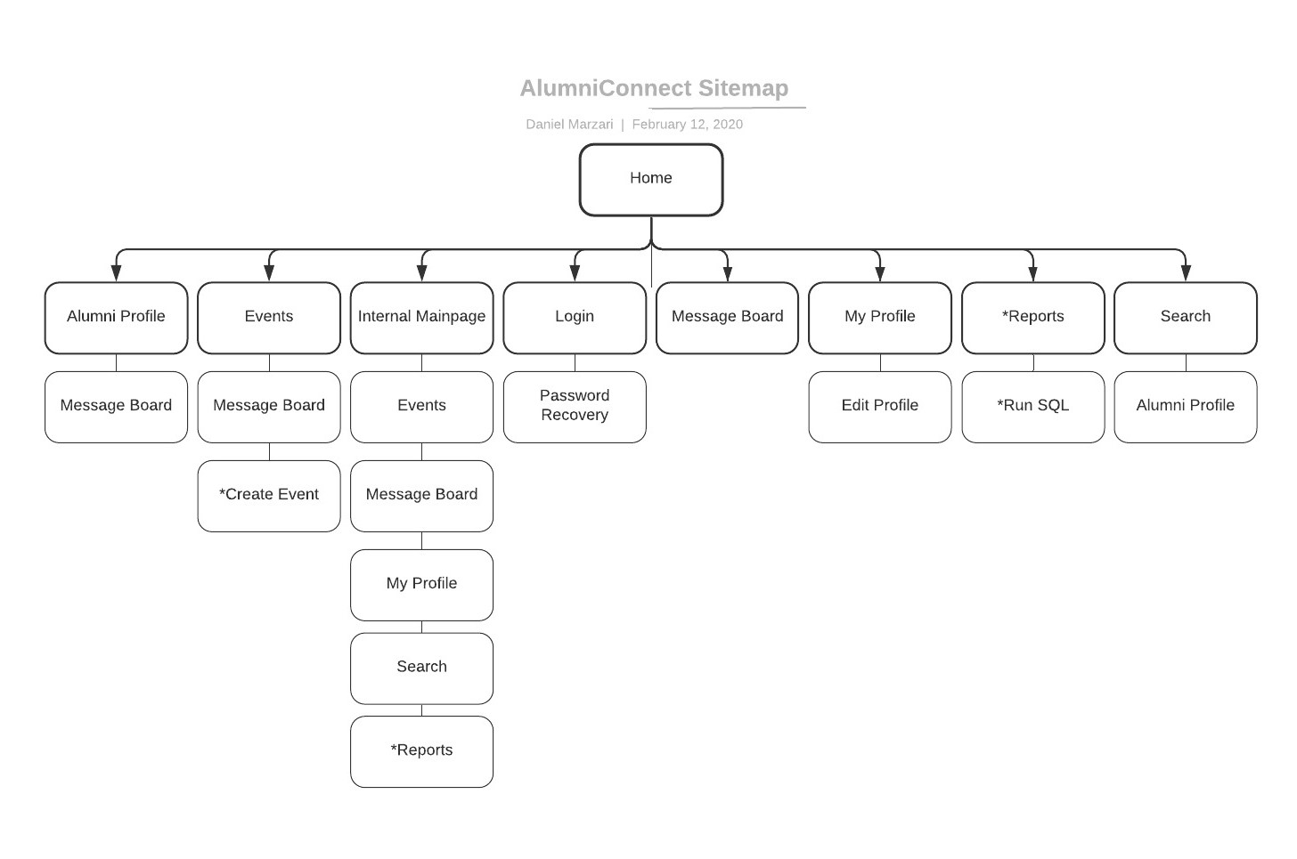

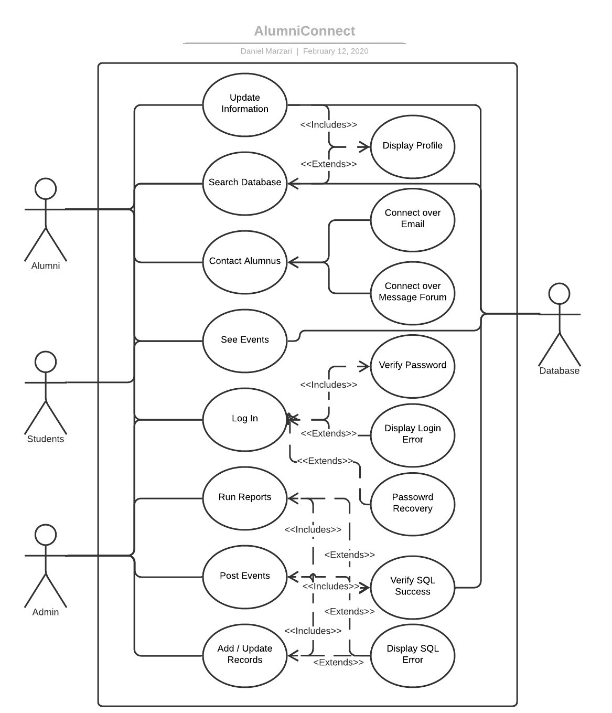

Alumni and students will be able to log on to an interface and see upcoming events at Cairn, browse the database and look up public contact information for other graduates and students, connect with alumni and to see the kinds of future jobs and opportunities they might have upon graduation, and update their own personal information. Administrators will have the aforementioned functionality as well as reporting tools, posting tools, and other tools for database updates and cleanup from the frontend.

**Building, Testing & Remediation (Phase III, IV & V) – 82 hours**

In these phases, all the requirements of AlumniConnect will be put into code to serve all the aforementioned functionalities. The database will be handled on an SQL server (phpMyAdmin) and written in JavaScript for the frontend and Java for the backend. The system will be thoroughly tested for efficacy, usability, and aesthetic presentation before this phase is complete. All bugs and errors will be fixed including major changes to the database or larger system. Due to the unpredictability of these phases there will be a 15% contingency in case of any significant roadblocks.

**Deployment & Hypercare Support (Phase VI & VII) – 5.5 hours**

During these phases, the product will be deployed for use and support will be offered for any user bugs that were not identified in the testing environment. The product will require additional support and monitoring incase the system crashes or there are any significant errors. The unpredictability of users and deployment into a non-virtual environment, this phase will also have a 15% contingency.

**Training, Documentation & Ongoing Support (Phase VIII, XI & X) – 30 hours**

In these phases, documentation and training material will be developed to record the functionality of the system and how to use it. It will record the final state of the developed software and any changes to the initial user requirements. After this phase, users are expected to use the system regularly, and ongoing support will be provided for any unlikely bugs and for updates to advance the software. The bulk of this phase will be spent training alumni, students and system administrators on how they can use the system, and take advantage of its functionality.

**Quote Total**

Estimations indicate a total expense of $13,500 with a 15% contingency for a total of $15,500. A total of 135 hours will be invested in the product and it is expected to be fully operational by mid-April. The project will last about three months and have 10 phases (Planning, Design, Building, Testing, Remediation, Deployment, Hypercare Support, Training, Documentation, and Ongoing Support). The bulk of this time will be spent building and testing the software. For a timeline and more details see the attached sheet.

**Signed Agreement**

Client Signature Consultant Signature

x_________________________ x____________________________